**OCTAL TO BINARY USING C**

**AIM:**

To write a C program to implement Octal to Binary using C.  
  
  
  
  
  
**ALGORITHM:**  
  
  
1)      Store  
the remainder when the number is divided by 8 in an array.  
  
  
2)      Divide  
the number by 8 now  
  
  
3)      Repeat  
the above two steps until the number is not equal to 0.  
  
  
4)      Print  
the array in reverse order now.

**PROGRAM:**

#include<stdio.h>

#include<math.h>

int OctalToDecimal(int n) {

int p = 0, decimal = 0, r;

while(n>0){

// retrieving the right-most digit of n

r = n % 10;

// dividing n by 10 to remove the

// right-most digits since it is already

// scanned in previous step

n = n / 10;

decimal = decimal + r * pow( 8 , p);

++p;

}

return decimal;

}

int main() {

int n, i, k;

printf("Enter Octal: ");

scanf("%d", &n);

printf("\nDecimal of Octal Number %d is : %d", n,OctalToDecimal(n));

return 0;

}

**INPUT & OUTPUT:**

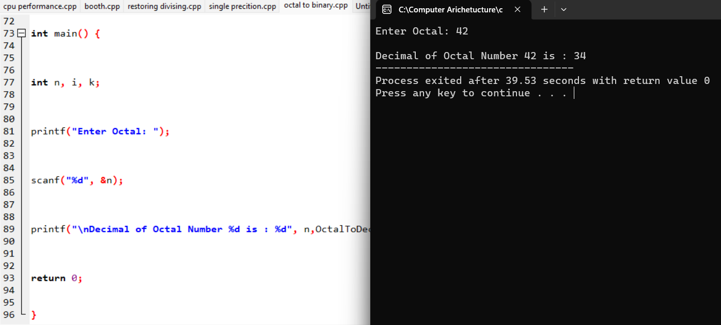

**RESULT:**

Thus we can write the program for Octal to Binary in DEV C++.